Given an array of integers nums and an integer target, return *indices of the two numbers such that they add up to target*.

You may assume that each input would have ***exactly* one solution**, and you may not use the *same* element twice.

You can return the answer in any order.

Answer:-

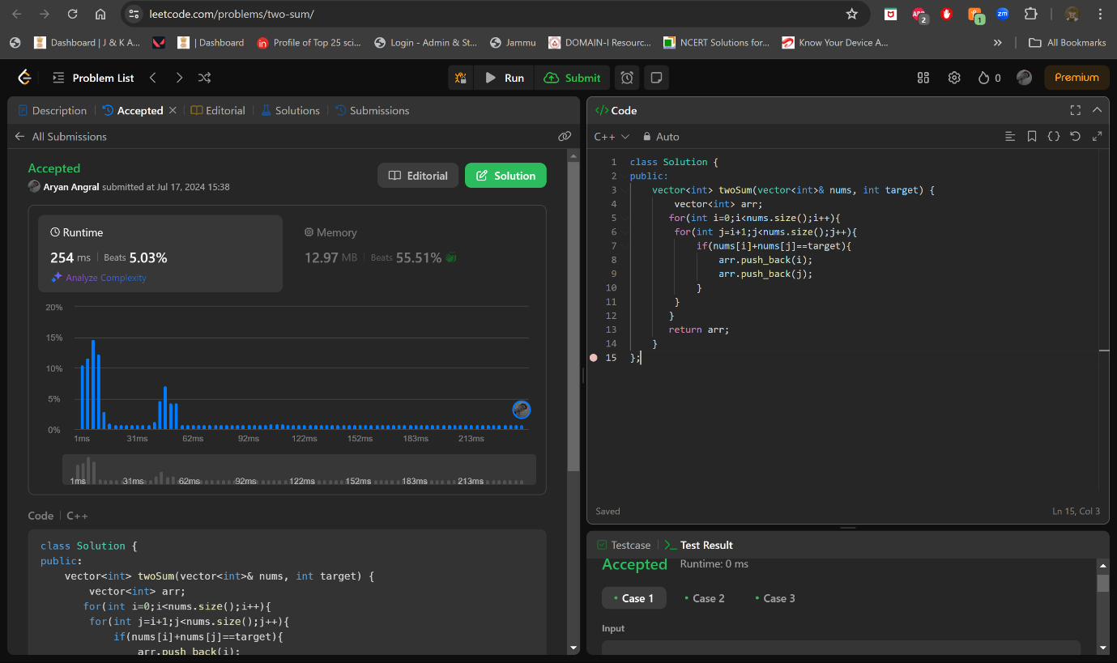

Code:-

class Solution {

public:

    vector<int> twoSum(vector<int>& nums, int target) {

        vector<int> arr;

       for(int i=0;i<nums.size();i++){

        for(int j=i+1;j<nums.size();j++){

            if(nums[i]+nums[j]==target){

                arr.push_back(i);

                arr.push_back(j);

            }

        }}

       return arr;

    }

};